10th August- 24th August 2026 
Services Across The Benefice
Thursday 13th August
9.30am @ St Andrew’s Church, Countesthorpe (Holy Communion)

Sunday 16th August
9am @ St Andrew’s Church, Countesthorpe (Holy Communion)
11am @ St Mary’s Church, Willoughby Waterleys (Morning Praise)

Thursday 20th August
9.30am @ St Andrew’s Church, Countesthorpe (Holy Communion)

Sunday 23rd August
9.15am @ St Bartholomew’s Church, Foston (Holy Communion)
11am @ St Andrew’s Church, Countesthorpe (Morning Praise with Holy Communion)

Collect Sunday 16th August
O God, you declare your almighty power most chiefly in showing mercy and pity: mercifully grant to us such a measure of your grace, that we, running the way of your commandments, may receive your gracious promises, and be made partakers of your heavenly treasure; through Jesus Christ your Son our Lord, who is alive and reigns with you, in the unity of the Holy Spirit, one God, now and for ever.

Collect Sunday 23rd August
Almighty and everlasting God, you are always more ready to hear than we to pray and to give more than either we desire or deserve: pour down upon us the abundance of your mercy, forgiving us those things of which our conscience is afraid and giving us those good things which we are not worthy to ask but through the merits and mediation of Jesus Christ your Son our Lord, who is alive and reigns with you, in the unity of the Holy Spirit, one God, now and for ever.
Morning Prayer
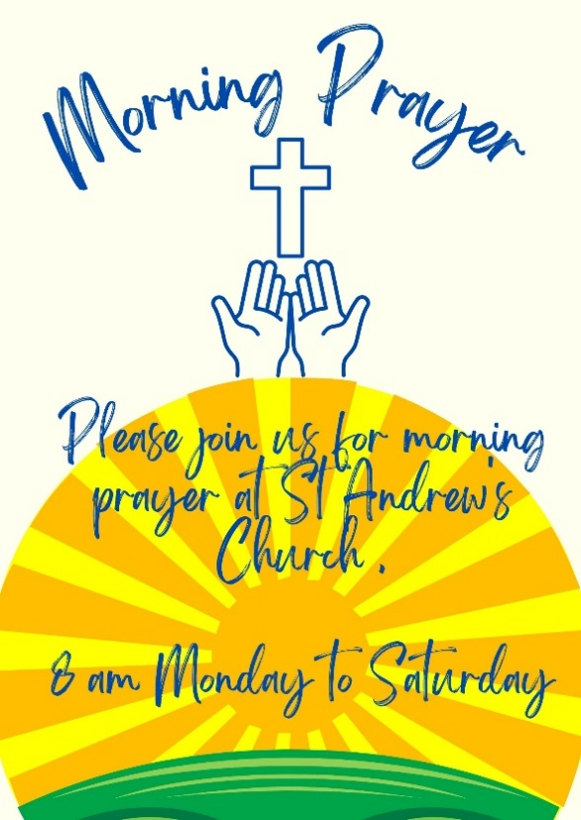
Please join us for morning prayer Monday- Saturday 8am- 8.30am

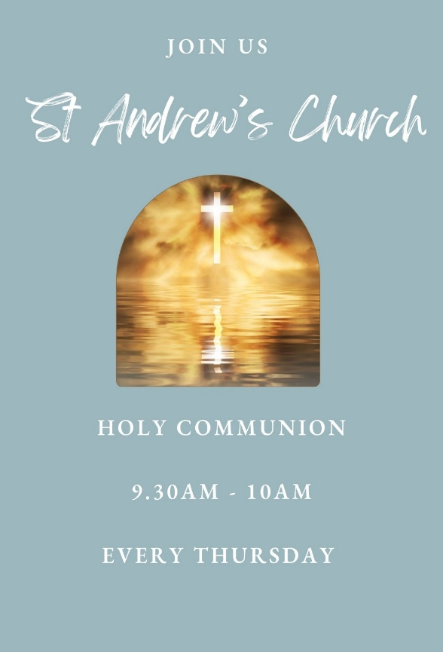
Thursday Morning Communion

NOTICES

As we look to the rest of the year ahead, our long-serving churchwarden, secretary, and treasurer are preparing to step down after many faithful years of service. Their dedication has been a blessing, and we are deeply grateful for all they have given.
Their departure leaves us with an important invitation: to consider whether God might be calling us to step forward. Many of us feel tired or unsure what we could offer, yet God often works through ordinary people who simply make themselves available.
These roles are not just administrative tasks—they are ministries that help our church remain healthy, hopeful, and ready for the future. No one would be left unsupported; training and companionship would be offered throughout.
Please pray, reflect, and listen for God’s gentle prompting. Even a small stirring of willingness may be the beginning of something life-giving for you and for our church. Richard
🌿 GARDEN PARTY 🌿
A huge thank you to everyone who helped make this year’s Garden Party such a wonderful success!
Whether you helped organise, baked, donated, set up, ran a stall, served refreshments, volunteered your time, or simply came along and enjoyed the afternoon — thank you! Every contribution made a difference. We are absolutely delighted to have raised a magnificent £1,113 towards our Restoration Fund. 🎉 Our Garden Party is our biggest fundraiser of the year, and it is only possible because of the incredible generosity and support of our church family and the wider community.
Thank you for helping us keep St Andrew’s at the heart of our community and supporting our urgent Restoration Project. ❤️
*There are two white tables missing if anyone has seen them, please let Emma know- thank you *

All Saint’s Church, Peatling Magna Coffee Morning
Please join us on the first Saturday of every month for our Coffee Morning, we have cakes, bacon cobs and a book Stall. All in aid of
church funds, 10-12pm

LOOSE CHANGE APPEAL
The donations placed into the Loose Change Jar during July amounted to £23.00
making the total banked to date: £1828.60
Another month has elapsed and the donations placed into the Loose Change Jar have stayed consistent. All the money placed into the jar is making a difference so thank you to all who are contributing.
***Domestic Abuse Awareness Training***
Saturday 22nd August | 9.30am – 1:00pm
The Bridge
We are pleased to be hosting a Domestic Abuse Awareness Training session on Saturday 22nd August from 9.30am to 1.00pm at The Bridge. Refreshments will be provided.
This is an excellent opportunity to complete your training in a friendly, face-to-face environment, particularly if you find online training difficult or aren't confident using computers. The session will guide you through everything you need to know, with support available throughout.
Domestic abuse awareness is an important part of safeguarding, helping us to recognise the signs, respond appropriately, and support those who may be affected.
To book your place, please contact Emma Adams as soon as possible.

🌈 THE RAINBOW SHOP NEEDS YOU! 🌈
We're looking for volunteers to help cover vacant shifts on
Thursday afternoons and occasional Saturdays.
If you're interested or would like more information, please contact
Sally on 07969 103993. We'd love to hear from you!

Book Stop
I am hoping to start Book Stop in church soon. It will be a place where you can borrow books, purchase books and all donations will go to the Restoration Fund. There will also be home group resources, DVDs etc. If anyone has a bookcase, they no longer need, perhaps you would consider donating it so I can set everything up. If anyone would like to help me that would be brilliant. Thank you, Gail
Restoration Project
We are now really starting to push forward with our Restoration Project, as the work required on the tower is becoming critical and cannot be delayed. To help raise the £50,000 needed, I’ve begun sharing our appeal with the wider Countesthorpe community to build awareness of the situation and encourage local support. The total cost of the building work is approximately £100,000 but if we can get to £50,000, we then qualify for some grant schemes. It would make a huge difference if you could also share our JustGiving page with friends, family, neighbours, and on social media. The more people who see it, the closer we get to saving our historic church tower. Here’s the link: https://www.justgiving.com/team/standrewschurch
The latest figure for our pot is £30,000

Kids Group
Kids group at the 9am Services is now finished for the summer for all our amazing volunteers to have a rest. The group will be starting up again on the 6th September which we will all be looking forward to. To welcome everyone back the group will be holding a brunch in The Bridge after church on the 6th September for the children, parents and leaders- Have a great Summer all

Tea at the Tower
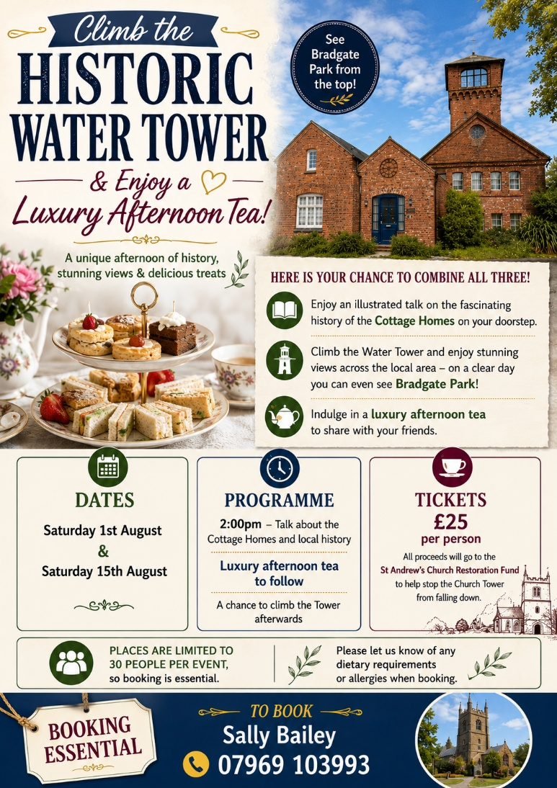

RIDE & STRIDE
12 SEPTEMBER 2026
We are now just 5 weeks away from this year’s Ride and Stride event. St Andrew’s will be open again this year and we are looking for support in several ways. Participants Sponsorship for participants. Stewards manning St Andrew’s to greet visitors. A list is at the back of church, please add your name. A list of all the churches and chapels participating in this event will be placed onto the board in church along with sponsor forms. Why not make this a family day out and visit as many buildings as you can using the list.
St Andrews will receive 50% of all sponsor money raised with the balance going to Leicestershire Historic Churches Trust. Because we are supporting this event we are entitled to ask for financial support for the repairs we need to carry out and to that effect Emma has obtained an application form.
If you need to know any more, please speak to either Karen or Geoff.

St Andrew's Art Exhibition
- This year will be on the weekend of 13th to 15th November.
- Half of the proceeds will go to an Alzheimer’s charity and half to the Church Building Fund
- The Cheese, Wine and Art evening will be on the Saturday 14th, with refreshments also served throughout the weekend. Please consider bringing your own art and invite your friends and neighbours to join us. This year, as well as painting, we'd love to see a whole range of mediums: from fabric to clay, printing, wood, digital and more. Nearer the time we will ask for some volunteers to help with setting up, serving refreshments etc. Hoping this will be a very enjoyable community event! Any questions, please contact Michelle Watkiss. Many thanks, Michelle



Contact information
Rev. Richard Reakes  Rector  Tel. 0116 2780907  Email: richard.vicarage@gmail.com  Day off: Monday | Rev. Mick Gillespie  Asst. Minister (PTO)  Tel. 2781130  Rev. Cam Wiltshire-Plant (Curate)  Tel. 07397197427  Email: cwpfoursaints@gmail.com  Day off: Saturday
June Ainge  Reader Minister  Tel. 07803 000285 | Helen Stokes  Associate Minister  Tel. 2778643
Lindsey Jelves  Reader Minister | Mike Oates  Associate Minister  Tel: 07484 647 683
Gail Mackley  Associate Minister  Tel: 2778982 | Jacqui McAughey  Associate Minister  Tel 07985 322 362
Gill Gillespie  Enrolling Member for the Mothers’ Union  Tel. 2781130 | Eva Morris  PCC Secretary  Tel. 2774622
Alison Dale  Treasurer  Tel 2772829  Benefice Administrator & Safeguarding Officer  Emma Adams  Tel. 0116 2778643  Email.standrewsoffice@hotmail.co.uk | Church Wardens @ St Andrew’s Church  Anne Jelves  Tel. 07970681199  Church Warden  Steve Bailey  Tel. 07970738760  If you're unsure about a tradesperson or quotation, Steve is happy to have an informal chat.  Please note that the church does not recommend or endorse individual tradespeople. We are happy to offer support and a second opinion if you are unsure.
Deputy Church Warden @ St Andrew’s Church  Sally Bailey  Tel. 07969103993  Honorary Church Warden  Josh Stokes | Premises Officer @ St Andrew’s Church & Kitchen Manager  Tony Cuthbert  Tel: 07713441254
Foston Church Contacts and Church Wardens:  Ros Dudley (2771856)  Ron Brookes (2789876) | Church Wardens @Peatling Magna  Warren Langley (07770  604213 )  Church Warden, Willoughby Waterleys - Vacant

